# ROM flow chart



# Key function design



# Other details

## 3.1 Image format

|  |
| --- |
| Header |
| tRoot FW |
| SPL signature |
| SPL Image |

The header structure is defined as following:

struct spl_header

{

uint32_t magic;

uint32_t version;

uint32_t img_type;

uint32_t spl_load_addr;

uint32_t spl_len;

uint32_t troot_fw_addr;

uint32_t troot_fw_len;

uint32_t signature_addr;

uint32_t signature_len;

uint32_t reserved[7];

};

Here, spl_load_addr is the runtime SRAM address for SPL to be running, troot_fw_addr is the runtime SRAM address for tRoot FW, in our design this is hard coded to 0x301C0000.

## OTP flags

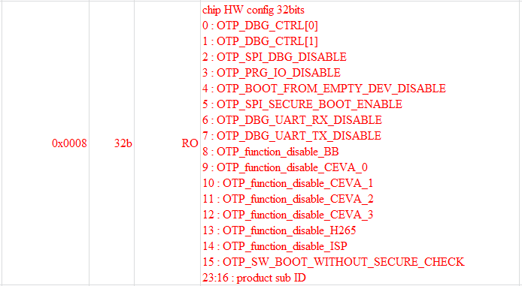

We use bit15 to determine whether to do the security check or not.

## Partition table

Both SPI Flash and EMMC use GPT as the partition table, which format is defined as following, will add more details later.

